EventHub Requirements Specification
1.0 Product Overview
EventHub is a web application that provides a place for members to organize and explore local events that interest them. An event on EventHub can be anything from a pickup football game to a nationally touring concert coming to your town. More specifically, EventHub empowers users to manage a personal account that includes creating and deleting events, following other members, and the ability to RSVP to events. EventHub also provides robust mechanisms which give users the ability to discover events around them. These mechanisms include an “event feed” view where all upcoming events can be seen. Also users have the ability to search events based on various parameters including date, type, and location. Finally users have the ability to follow other users' event creation. All of these features are provided via a reliable and robust back-end that provides enterprise-level reliability without compromising in flexibility. The software that runs EventHub has been battle tested in production environments for years on the largest of scales. Through all the powerful features that EventHub provides, the software breaks down the existing barriers that are in place for people to find events and meaningful experiences around them. No longer will a person be disappointed when they find out about a concert only after it happened or be frustrated when they did no hear about a pickup basketball game happening with some friends she hasn't been able to catch up with in a long time. No matter what the event though the key mission of EventHub remains the same: Help people find exciting, meaningful, and interesting things to do wherever they may find themselves.
2.0 Information Description
2.1 User Interface
See User Manaul section of software configuration.

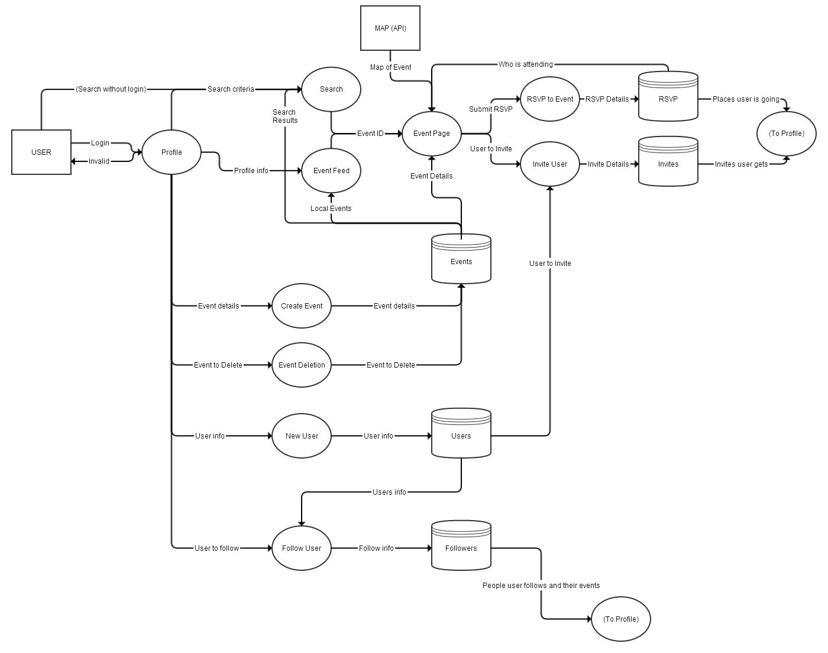
2.2 High Level Data Flow Diagram

2.3 Data Dictionary
2.3.1 Users Database:
  - User : User
    - Primary key for users database
  - Name : User
    - User name – the name the user chooses to be shown as online
  - Email : User
    - The user’s email address for communicating and alerts
  - Password : User
    - The user’s password salted and hashed with sha1
  - Location name : User
    - The name of the user’s location (eg. Pittsburgh PA)
  - Location : User
    - Latitude / longitude of the user’s location generated from the location name. Used for determining nearby events.
  - Picture : Picture
    - Link to picture database for profile picture.

2.3.2 Events Database:

  - Event : Event
    - Primary key for events database
  - Name : Event
    - Name of the event
  - Date : Event
    - Date and time of the event
  - Type: Event
    - They type of event this is going to be (eg. Sports, Music, Outdoors …)
  - Location Name : Event
    - Name of location given by user (eg. 123 Main st. Somewhere, CA 90210)
  - Location : Event
    - Latitude / longitude of the user’s location generated by location name
  - Description : Event
    - Event description (max 1000 chars)
  - Private : Event
    - Flag to indicate if event should show up in searches (set by user)
  - Picture : Picture
    - Link to picture database for event picture
  - User : User
    - Link to user database for creator of event

2.3.3 Invite Database:

  - Invite : Invite
    - Primary key for invite database
  - Event : Event
    - Event to invite to (links to event database)
  - User (Inviter) : User
    - User that is inviting (links to user database)
  - User (guest) : User
    - User that is being invited (links to user database)

2.3.4 Follow Database:

  - Follow : Follow
    - Primary key for follow database
  - User (Follower) : User
    - The user that is following another user
  - User (Followee) : User
    - The user that is being followed

2.3.5 RSVP Database:

  - RSVP : RSVP
    - The primary key for the RSVP database
  - Event : Event
    - The even to RSVP to (Link to event database)
  - User : User
    - The user that is RSVPing
  - Type : RSVP
    - A flag indicating the RSVP type (eg. Attending, Maybe, Not Going)

2.3.6 Pictures:

  - Picture : Picture
    - Primary key for picture database
  - User : User
    - The owner of the picture (Link to user database)
  - Path : Picture
    - Where the picture is stored on the filesystem
  - Type : Picture
    - The picture type (eg. .jpg, .png, …)
3.0 Functional Descriptions
3.1 New User
3.1.1 Description:
EventHub enables users to sign-up with a unique account that stores various information unique to that user. To sign up, a user must input his or her profile information into a registration form and click submit. The information entered by a user is error checked to ensure that it meets the minimum requirements of each input. The new user is prompted to correct errors, if any. Once the information entered in the form is valid, then the new user is entered into EventHub's user database. All users are stored in the user database. Once a new user is registered, the user is able to access her or her profile as well as EventHub's other features.
3.1.2 Design Constraints:
A new user is limited to providing only the information that is required in the registration form. A new user may provide a name, email, picture, and a short bit about themselves. New users can only sign up with a valid email address.
3.1.3 Data flow diagram
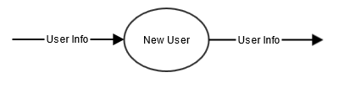
3.2 Follow Other User
3.2.1 Description:
People can follow other users on Eventhub. The following mechanism allows users to track which events other users create or RSVP to. Once a user has registered with a personal account, the user is able to log in and navigate to other users’ profiles. The user can then simply click the “follow” button on other user's profile to follow them. Both users are then notified. When a user follows another user, that relationship is stored in the followers database.
3.2.2 Design Constraints:
Users need an account to follow other users. Users cannot block other users from following them. However, users can only view other users that are interested in the same events as themselves (there is no user search at this time).
3.2.3 Data flow diagram
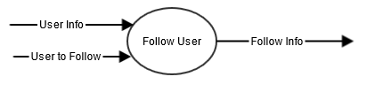
3.3 Event Creation
3.3.1 Description:
Users may create events on EventHub. Anyone with a valid EventHub account may create an event. To create an event, provide the necessary information (name, location, and type) and submit this form. After standard error checking, all events are submitted and stored in the events database. Once an event is created, the standard EventHub functionality associated with events is enabled. Users can perform EventHub’s standard event functions, such as search, RSVP, invite, and deletion for the created event. The original event creator serves as the sole administrator for the event.
3.3.2 Design Constraints:
Only EventHub users with a valid account can create events. Users can only create valid events. For example, a valid event must specify a time, place, and event type before it is created. Multiple users cannot create the same event. Users cannot transfer control of an event to other users. Event creators have no control upon who can view their event within the EventHub site.
3.3.3 Data flow diagram
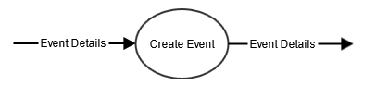
3.4 Event Deletion
3.4.1 Description:
An event creator can delete events. Users can delete events in the “My Events” section in their profile. Users can delete events that they have created and have administrator privileges for by simply clicking “Delete Event”. Once confirmed, an event is deleted. Once an event is deleted, it is irrevocably lost. And it is fully removed from the events database. This means that it will no longer be accessible from any feature within the rest of EventHub. For example, users can not search and find a deleted event and the event no longer can be seen on any user’s feed.
3.4.2 Design Constraints:
Only user that made an event can delete it. Users cannot delete events that have already occurred. Similarly, users cannot delete events once the event is in progress.
3.4.3 Data flow diagram
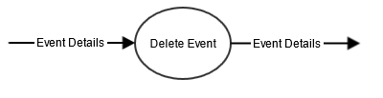
3.5 Event Search
3.5.1 Description:
Users are given the ability to search events. To search an event, a user must go to EventHub’s search page and enter specific search terms. Users may filter searches by location, event type, and date. After a user submits a search, a list of the most relevant events is provided. To find these results, EventHub queries the event database and selects the most relevant event data, based upon our industry gold standard search algorithm. Once a user selects an event to inspect, he is taken to an event page which displays the event's information.
3.5.2 Design Constraints:
Only EventHub users may search events. Search is limited by the provided search filters.
3.5.3 Data flow diagram
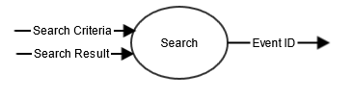
3.6 RSVP to an Event
3.6.1 Description:
Users may RSVP to an event. EventHub users can RSVP to an event by finding an event’s page and clicking the “RSVP” button. Users can RSVP to events they find via search, see on their feed, or are invited to. When a user RSVP’s to an event, this relationship is stored in the RSVP database. Users can see who is RSVP’d to an event via viewing the event details, or looking at their feed of followed users. Users can RSVP to a limitless number of events. In fact, it is encouraged.
3.6.2 Design Constraints:
Only registered EventHub users may RSVP to an event. There is no functionality to deny users from RSVP’ing to an event.
3.6.3 Data flow diagram
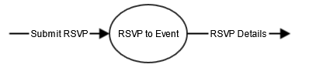
3.7 View Event Feed
3.7.1 Description:
Users can view their event feed. To view an event feed, a user must navigate to his or her profile where the event feed will be listed. The event feed provides a real time display of events that are relevant to the user. Users see events flow across their event feed that their followers RSVP’d to, or that they RSVP’d to. The event feed serves as both a reminder and a notification of events that are of interest to the user. Event data from the event database, followers database, and RSVP database fuels the event feed.
3.7.2 Design Constraints:
Users can only see events on their event feed which they are directly connected with. For example, the feed only shows events that their followers and those they followed, along with pending event invites. Other events, like nearby events, that the user has no connection with will not display on a user’s event feed.
3.7.3 Data flow diagram
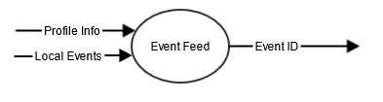
3.8 Invite User to Event
3.8.1 Description:
Users can invite other users to an event. To invite another user to an event, a user can do one of two things. First, a user may navigate to another user’s profile, click “invite, and specify which event. Second, a user may invite multiple users to the same event by going to an event’s page and clicking “invite users”. Once a user is invited to an event, the relationship is stored in the invites database. When a user is invited to an event, a user is able to RSVP for that event.
3.8.2 Design Constraints:
Users can only invite other users to events which they either RSVP’d for or created. Users can only invite other registered users to an event.
3.8.3 Data flow diagram
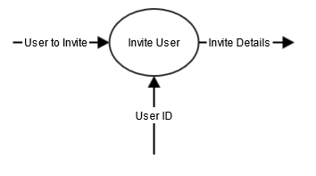
3.9 Event Map
3.9.1 Description:
Users may view EventHub’s event map. The event map uses the Google Maps API to display pins of event locations. Users will enjoy the same functionality as Google Maps. Users can view events on the map and click on each event to either learn a little bit about that event or navigate to the event’s EventHub page. The event map uses an outside API for its functionality.
3.9.2 Design Constraints:
The event map is limited in functionality by the Google Maps API. We will not be providing additional features that are not offered by the Google API.
3.9.3 Data flow diagram
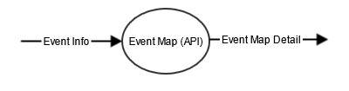
Note: IC Cards for each function can be found in attached documents.
4.0 Performance Requirements
EventHub’s performance requirements stress the importance of opportunities for community growth and fast query searches. In order to quickly provide search results for users, the size of the community must be scaled to a point that takes into account the load the server is able to handle at a given time. Along with search query speed, EventHub considers the login process, profile editing, and event creation to be services that require speedy completion.
At any given time, EventHub is expected to handle at least 300 concurrent users. The capacity to handle larger amounts of activity is expected to increase if greater server resources become available. In terms of the total number of profiles in the database, EventHub will handle around 1,000 profiles in its developing stages. The capacity to handle many more profiles is certainly available; however, there is no purpose in hosting a large number of accounts if only a small percentage of those accounts are able to be active at any given time. With an expectation of at least 30% of the total community being active at a given moment (300 active / 1,000 total), EventHub expects services to run smoothly.
In terms of search speed, EventHub expects event search queries to take place in under two seconds. Given that the average number of search results for any given query is ten, two seconds is the maximum amount of time it should take to process each search result and provide relevant information about each result to the user.
The login process, submitting profile changes, and creating new events should take under one second to complete. These three kinds of interactions with EventHub are indicative of simple database interactions; thus, their completion times are faster than search query times, which involve pulling multiple results from the database as well as performing certain calculations such as distances from events.
5.0 Exception conditions/exception handling
The intention of EventHub is to bring communities together with an easy to use tool that can coordinate events. One of the most essential qualities in any service is dependability. If users do not comfortably feel that EventHub is reliable and stable, then they will choose another service. For instance, if a user hosts a party event, people RSVP, and then the page goes down the date of the party, frustrated users would not be able to see that it was canceled. That is a good way to lose your user base.
EventHub has a system for dealing with exceptions since they are bound to happen with such a wide variety of users and configurations. On the user level, there is an easy way to report bugs on the homepage by clicking “report”, classifying the occurrence and writing a brief description. These reports are read and logged by the tester. The tester then investigates the problem and attempts to find the cause. These results are compiled into an error report and sent to the programming team to be resolved.
In the event of an urgent exception, decisions fall to the chief programmer. For example, if the webservers are compromised in some way, be it someone spilled water on one, or installed problematic software, the chief programmer has the executive decision on how to proceed. Situations like these are unpredictable, so it is important to have procedure. However, given the nature of these cases, allotting all resources to the most qualified person is the most practical response so that they can assess the situation and make the appropriate call. The chief programmer can choose to counsel with his team or delegate responsibility.
Data is recorded for all traffic that comes through EventHub. If the website crashes, all team members doing non-essential work will be put toward diagnostics and getting the site back online. Once the site is up, the tester will write a crash report and submit it to the chief programmer. The chief programmer will ultimately decide what to do—to get more server space, bandwidth, etc. Preventative measures are taken to avoid crashes, such as tracking traffic and predicting spikes.
6.0 Implementation Priorities
Core functionality:
- Create User
- Delete User
- Create Event
- RSVP Event
- Search Event
Additional Functionality:
- Follow User
- Invite User to Event
- Event Feed
- Map Events
7.0 Foreseeable modifications and enhancements
For the Create User function, we may enhance what type of information a user may provide. Additional information may include multiple photos, interests, past attended events, etc. These can be used to enhance a user's profile.
The search event function has a vast ceiling for enhancement. The basic version gives the user limited search features. Possible enhancements include expanded search parameters. Users could also sort results by multiple parameters after searching. Also, the search function may at some point integrate with the Map Event function, showing search results both in text and map form.
The Create Event function can add the following enhancements. Event creators may at some point provide certain restrictions to the events. For example, an event creator may create some sort of privacy level, like location, age group, or something along those lines. This gives more flexibility to event creators.
8.0 Acceptance criteria
Testers will assure that EventHub runs smoothly by performing a thorough evaluation. Each function of the site will be tested with each significant permutation and documented. As new functions are added, the tests will be run again. All actions and the results will be recorded on the test report, if it is a success or failure compared to the expected result. If there is an error, all preceding action is documented. In the case of an error or glitch, the tester will write up a separate error report. In the case that the testing is using too much resources, test stubs will be made. Before dynamic testing is started, the programmer who made the code and another tester will go through the code together and search for possible errors.
First the login process will be tested. Logins will be made with the required specifications and checked to see if they worked properly. Then incorrect login and password combinations will be tried and if there are any that work, it will be noted in the test report and an error report will be made. Then changes will be made to the profile. The username and password will be changed and all combinations tried again. All login interactions should take under a second.
Multiple computers and accounts are then used to check the functions such as follow user, RSVP, and editing event pages. Thirty fake accounts and events are made, each with completely different location, tags, and details. All event pages are inspected for accuracy—changing the amount of RSVPs, changing location, and canceling events are all tested. When an event is cancelled, those who RSVPed should get notified. The event feed must have the recent activity of followed users and be able to update quickly. If the resources are available, the server can be tested full scale by running 300 accounts at once.
9.0 Sources of information
Server:
http://php54.nfshost.com/
PHP:
http://php.net/
Javascript:
http://www.w3schools.com/js/
JQuery:
http://jquery.com/
HTML5:
http://www.w3schools.com/html/html5_intro.asp
Google Maps API:
https://developers.google.com/maps/documentation/javascript
10.0 Revision History
Date | Section | Description
10/15/13 | 2.2 | Removed excess databases from DFD

